**Music Control Using Web Application**

**A MINI PROJECT REPORT**

***Submitted by***

**S V SAI SUPREETH - 212219220059**

**CHANDRU - 212221220007**

***in partial fulfillment for the award of the degree***

***of***

**BACHELOR OF TECHNOLOGY**

**IN**

**INFORMATION TECHNOLOGY**

 

**DEPARTMENT OF INFORMATION TECHNOLOGY**

**SAVEETHA ENGINEERING COLLEGE, THANDALAM.**

**ANNA UNIVERSITY: CHENNAI 600 025**

**DEC 2022**

**ANNA UNIVERSITY: CHENNAI 600 025**

**BONAFIDE CERTIFICATE**

Certified that this project report “**MUSIC CONTROL USING WEB APPLICATION**” is the bonafide work of **S V SAI SUPREETH (212219220059) , CHANDRU (212221220007) ,**who carried out the project work under my supervision.

**SIGNATURE**

**Dr. N. VELMURGAN,**

**SUPERVISOR**

**ASSISTANT PROFESSOR**

Department of Information Technology,

Saveetha Engineering College,

Saveetha Nagar, Thandalam,

Chennai-602105

**SIGNATURE**

**Dr. K. Suresh Kumar,**

**HEAD OF THE DEPARTMENT**

**ASSOCIATE PROFESSOR**

Department of Information Technology,

Saveetha Engineering College,

Saveetha Nagar, Thandalam,

Chennai-602105



Submitted for VIVA-VOCE held on **………………**

**INTERNAL EXAMINER EXTERNAL EXAMINER**

**ACKNOWLEDGEMENT**

I wish to express my gratitude to our Founder President **Dr. N.M. Veeraiyan**, Director **Dr. S. Rajesh,** Saveetha Engineering College, for their guidance and blessings.

I am very grateful to our Principal **Dr. N. Duraipandian M.E., Ph.D.,** for providing me with an environment to complete my project successfully.

I am indebted to our **Head of the Department, Dr. K. Suresh Kumar, M.Tech., Ph.D., for** his support during the entire course of this project work.

I am indebted to our **supervisor Project, Dr. N. VELMURGAN , M.Tech., (Ph.D.),Assistant Professor ,** Department of Information Technology, Saveetha Engineering College, for assisting me in the completion of my project with his/her exemplary Guidance and for his/her support during the entire course of this project.

My heartfelt thanks to the **Project Coordinator, Dr. K. Suresh Kumar, M.Tech., Ph.D., Associate Professor,** Department of Information Technology, Saveetha Engineering College, for unstinted support throughout this project.

I also thank all the staff members of our department for their help in making this project successful.

**ABSTRACT**

Music has been a way for people to reduce their stress and since we all have a variety of emotions, music comes in all types of styles. As streaming is increasingly being adopted by users, online media players have become essential for consuming media on the internet.

Music players allow one to enjoy music in any browser and supports a lot of the features of an offline music player. We will be creating a music player with a clean user interface that can be used to play music in the browser. We will also implement features like seeking. HTML has several methods in the HTML Media Element interface that can be used to play audio files and control its playback without using any other library.

We will start by creating the HTML layout first that defines the structure of the player, make it look good by styling using CSS, and then write the player logic for all the functions in JavaScript

## Table of Contents

|  |  |  |
| --- | --- | --- |
| **Chapter Number** | **Title** | **Page Number** |
|  | **Abstract** | 3 |

|  |  |  |
| --- | --- | --- |
| **1**  **2**  **3**  **4** | **List of figures List of tables**  **List of Abbreviations INTRODUCTION**   * 1. Overview of the project   2. Scope and Objective   **LITERATURE SURVEY**   * 1. Introduction   2. Literature Survey   **SYSTEM DESIGN**   * 1. Introduction   2. Existing System   3. Proposed System   4. System Architecture Diagram   5. Data Flow Diagram   6. UML Use Case Diagram 3.7Activity Diagram   3.8 System Requirements  **IMPLEMENTATION AND ANALYSIS**  4.1 Music player.html | 7  9  9  9  10  10  11  14  14  16  16  17  17  19  20  21  22  23  33  42 |

|  |  |  |
| --- | --- | --- |
| **5**  **6**  **7** | * 1. Player.css   2. Data.js   3. App.js   4. Output   **Test Plan And Testing**   * 1. Testing   2. Testing Objective   3. Type Of Test      1. Unit Testing      2. Integration Testing   4. System Test      1. White Box Testing      2. Black Box Testing      3. Unit Testing   **Result And Observation**   * 1. Result   2. Observation **Conclusion References** | 47  53  56  56  56  57  57  57  58  58  59  59  60  60  60  61  62 |

**LIST OF FIGURES**

|  |  |  |
| --- | --- | --- |
| **Figure No.** | **Title** | **Page No.** |
| 3.4.1 | System Architecture Diagram | 13 |
| 3.5.1 | Data Flow Diagram | 15 |
| 3.6.1 | Use Case Diagram | 16 |
| 3.7.1 | Activity Diagram | 17 |

## LIST OF ABBREVIATIONS

UI - User Interface

JS - Java Script

HTML - Hyper Text Markup Language DOM - Document Object Model MGC - Music Genre Classification PHP - Hypertext Preprocessor

MYSQL - My Structured Query Language SVM - Support Vector machine

DFD - Data Flow Diagram

UML - Unified Modelling Language CSS - Cascading Style Sheets

GHz - Gigahertz

GB - GigaBytes

MB - MegaBytes

# CHAPTER 1 INTRODUCTION

## OVERVIEW OF THE PROJECT

Song is something that all of us revel in within the route of our lives. it's miles the sound that is delivered collectively via a concord of devices and making a song voices. So we are providing “mini song controller” a basic net application with easy UI. If you want to simply listen to the tune you don’t must browse over the internet.

## SCOPE AND OBJECTIVE

**SCOPE**

The main goal is to develop a track controller that tune has been a way for people to reduce their stress and we all have a diffusion of emotions. As streaming is increasingly being followed by

means of users, on-line media players have grow to be vital for consuming media at the internet.

## OBJECTIVE

That is an easy-tune participant with an easy and delightful UI. You can skip tracks , play a preceding tune, pause it for a while and it actually have a progress bar which help you change the song of the tune. The goal of this mission is to recognize how js manipulates Html dom that offers an internet page the dynamic property.

# CHAPTER 2

**LITERATURE SURVEY**

## INTRODUCTION

Literature survey is the most crucial step within the software program development process. before Growing the device it's far necessary to decide the time issue, financial system and employer electricity. once the programmers begin building the device the programmers want numerous external help. This aid may be received from senior programmers, from books or from websites. earlier than constructing the machine, the above issues are taken into consideration for growing the proposed gadget. a main part of the challenge development sector considers and fully surveys all the required needs for growing the mission. For every project, the Literature survey is the most essential region within the software development technique. before developing the tools and the related designing it is important to determine and survey the time issue, resource requirement, manpower, economy, and agency strength.

## LITERATURE SURVEY

1. layout and Implementation of an internet-based song Portal: F . Abdullahi, J .C .Kisha, T Hassan.

This examination is aimed toward growing an internet-primarily based tune Portal which can be used to manipulate a musical library and an image gallery. it's miles aimed to update the guide gadget of getting musical CDs thinking about the technology development. The examination discusses the arena extensive net (www) as a web carrier that permits the distribution of pages. Familiarity with web primarily based software; web programming and internet improvement as an enterprise are also mentioned. It additionally consists of the system evaluation and layout which include the numerous download and add mechanisms. The gadget layout, file and

database layout is given based on the specific of the proposed machine. The implementation and upkeep of the device accommodates the software development, software program checking out and debugging as nicely as software program implementation. The implementation of the system is carried out the use of Apache as web server with extended guide for Hypertext Preprocessor and MYSQL.

1. internet based totally tune participant In Angular JS With NodeJS : Shivam Kumar Mishra Track genre classification (MGC) is a area of the music annotation area that has these days Obtained attention from the MIR research network, mainly since the seminal look at of Tzanetakis and prepare dinner [5]. the main objective in MGC is to classify a musical piece into one or extra musical genres. As simple as it sounds, the field still provides challenges related to the shortage of standardization and indistinct style definitions. Public databases and ontologies do now not normally agree on how each genre is described. moreover, human music notion, problem to evaluations and personal experiences, makes this settlement even extra difficult.

for instance, when a tune includes swing rhythms, piano, trumpets and improvisation, we might in all likelihood outline it as jazz song. however, if we introduce synthesizers inside the same song, ought to the song be categorized as digital tune as nicely? If we simplest recall acoustic traits, the answer is probably sure. however specific listeners can understand the piece from their very own perspective. while some might categorize the track as jazz, others would possibly take into account it digital tune or maybe a mixture of each.

1. An internet application for audience Participation in stay song performance: Mathieu Barthel , Leshao Zhang and Yongmengu

In this paper we endorse an internet utility that allows audiences to co-create musical performances with performers in an interactive manner thru voting and visualization . The machine is scalable to massive audiences and enables quasi actual time audience-performer interactions. It makes several novel contributions to participatory live tune performance systems interactions are mediated thru a vote casting system that can be operated through audiences from a web purchaser

utility on their cell devices, audience-to-performer grouping assignments are automated primarily based on purchaser connection, audience individuals are attributed unique virtual identifiers which may be tracked for customized feedback and evaluation purposes, quasi real-time visualizations are generated by means of a visual client following audience-driven creative facts.

1. web-primarily based song style classification for Timeline music Visualization and analysis: Jaime Ramirez Castillo and M. Julia Flores

This paper presents an internet software that retrieves songs from YouTube and classifies them Into track genres. The tool defined in this look at is primarily based on fashions educated the usage of the musical collection information from Audio set. For this cause, we've got used classifiers from awesome system mastering paradigms: Probabilistic Graphical models (Naive Bayes), Feed-forward and Recurrent Neural Networks and support Vector Machines (SVMs). These kinds of models had been educated in a multi-label category scenario. Because genres might also vary alongside a track's timeline, we perform class in chunks of ten seconds. This

functionality is enabled with the aid of Audio set, which gives 10-2nd samples. The visualization output gives this temporal statistics in actual time, synced with the music video being performed, providing type consequences in stacked vicinity charts, in which ratings for the top-10 labels acquired in step with chew are shown. We briefly give an explanation for the theoretical and clinical foundation of the trouble and the proposed classifiers. subsequently, we show how the software works in practice, the use of 3 awesome songs as cases of have a look at, which are then analyzed and compared with online categorizations to talk about models performance and song style category demanding situations.

# CHAPTER 3 SYSTEM DESIGN

## INTRODUCTION

layout is a multi- step that focuses on information shape software program architecture, procedural info, algorithm and interface among modules. The design manner also interprets the necessities into presentation of software that may be accessed for pleasant earlier than coding starts. Systems design could be visible as the software of structures idea to product development. there is a few overlap with the disciplines of structures analysis, systems architecture and structures engineering. till the Nineties, structures layout had a vital and respected role within the statistics processing enterprise. within the Nineteen Nineties, standardization of hardware and software program resulted in the potential to construct modular structures. The growing significance of software program going for walks on everyday structures has enhanced the discipline of software engineering. The architectural design of a system emphasizes the design of the device architecture that describes the structure, behaviors and extra views of that machine and evaluation. It is supposed to fulfill particular desires and necessities of a enterprise or company thru the engineering of a coherent and nicely-jogging gadget. They wished on the way to standardize their paintings into a formal area with proper strategies, specially for brand new fields like information principle, operations research and pc science in widespread. pc software program design changes continuously as new strategies; higher analysis and border know-how evolved. software program layout is at a pretty early degree in its revolution. consequently, software design methodology lacks the depth, flexibility and quantitative nature which might be usually associated with greater classical engineering disciplines. but techniques for software program designs do exist, criteria for layout traits are available and design notation can be implemented.

## EXISTING SYSTEM

If it's far cell, all people use cellular packages like Apple song, Spotify, Ghana to listen to music. but on the subject of employed adults and students, its no longer the case. most people Hate To maintain more application in machine. They favor to use Browsers as they browse all of the time

.They maintain player on within the background and do their works. So nevertheless there are numerous internet packages out there to play tune in internet however the UI they offer have lot of things you recognize.. extra facts has to be transferred between customer browser and server.so from time to time it takes time to load the whole thing and play a track. And its difficult when you have negative internet connection they wont load in any respect.it'd worsen us.

## PROPOSED SYSTEM

* This challenge provides music app which offers top songs from all the languages.
* This app has a speciality in which songs can be downloaded inside the app and we will pay attention them in offline.
* It additionally have length of the song contemporary time as well as duration of the music performed.
* you can upload a tune to preferred.

## SYSTEM ARCHITECTURE DIAGRAM

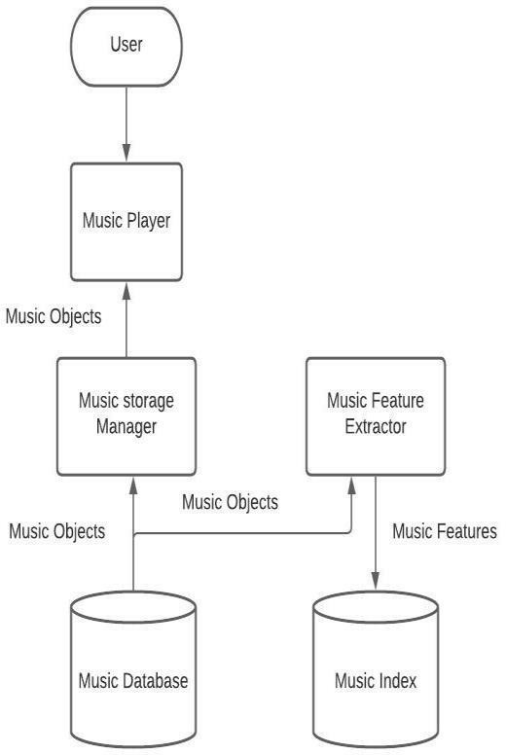

**Fig:3.5.1**

## DATA FLOW DIAGRAM

Data flow Diagram (DFD) is a -dimensional diagram that describes how records is processed and transmitted in a machine. The graphical depiction acknowledges every source of facts and the way it interacts with other facts resources to reach a mutual output. on the way to draft a facts flow diagram one need to

* perceive outside inputs and outputs
* decide how the inputs and outputs relate to every other
* give an explanation for with snap shots how those connections relate and what they result in.

## ROLE OF DFD

* It's miles a documentation assist which is understood via both programmers and

nonprogrammers. As DFD postulates handiest what tactics are achieved now not how they're done.

* A bodily DFD postulates wherein the data flows and who strategies the information.
* It lets in analysts to isolate areas of interest within the company and examine them via inspecting the records that enter the manner and viewing how they are altered after they leave.

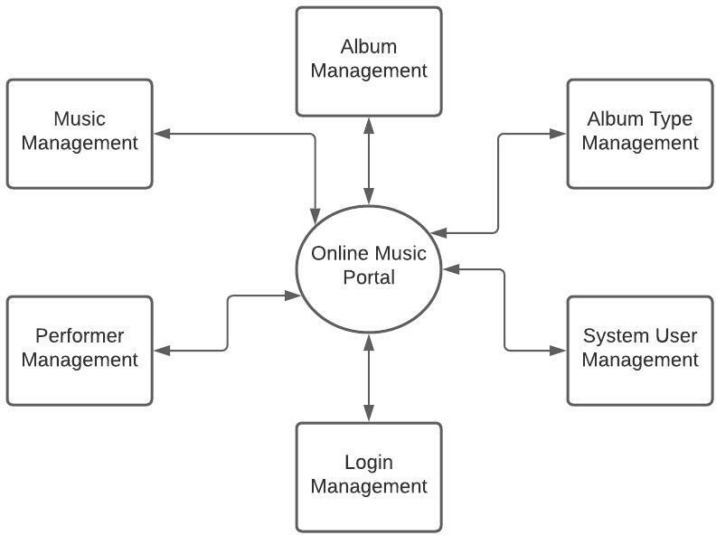

**Fig:3.6.1**

## UML DIAGRAMS USE CASE DIAGRAM

A use case diagram at its handiest is a representation of a consumer's interaction with the gadget that indicates the relationship among the user and the unique use cases wherein the consumer is concerned. A use case diagram can perceive the distinctive kinds of users of a system and the

distinct use cases and will often be accompanied by using other forms of diagrams as nicely. The use instances are represented by means of either circles or ellipses.

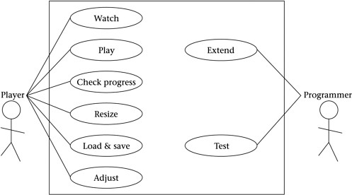

**Fig:3.7.1**

## ACTIVITY DIAGRAM

Interest diagrams are graphical representations of workflows of stepwise sports and moves with assist for choice, new release and concurrency. in the Unified Modelling Language, pastime

diagrams are supposed to version each computational and organizational tactics (i.e., workflows),

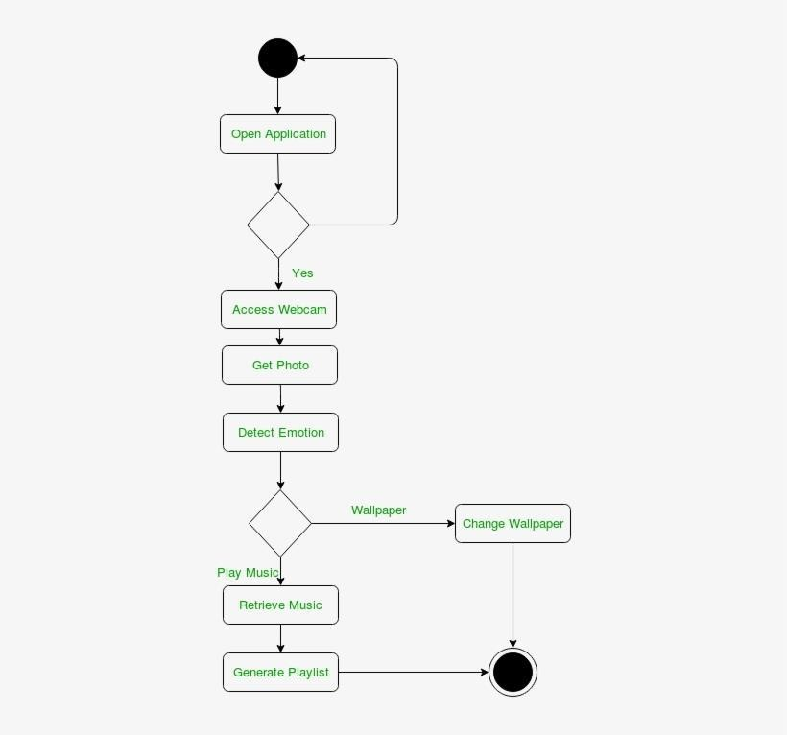

**Fig:3.8.1**

## SYSTEM REQUIREMENTS

**HARDWARE REQUIREMENTS:**

* System - Pentium-IV
* Speed - 2.4 GHZ
* Hard disk - 40 GB
* Monitor - 15 VGA color
* RAM - 512 MB

## SOFTWARE REQUIREMENTS:

* Operating System - Windows 10
* Coding Language - Javascript
* Front End – HTML,CSS

# CHAPTER 4 IMPLEMENTATION AND ANALYSIS

Implementation is the tiers of the challenge when the theoretical design is turned out right into a running system. thus it can be considered to be the maximum essential stage in achieving a successful new device and in giving the consumer, self belief that the new machine will work and be powerful The implementation degree entails careful planning, research of the existing device and it’s constraints on implementation, designing of the techniques to achieve modifications over and assessment of changeover methods Implementation is the system of converting a new system design into operation. it is the phase that specializes in consumer education web site practise and report conversion for putting in a candidate machine. The essential aspect that need to be considered here is that the conversion have to no longer disturb the functioning of the company. **Music_player.html :**

<html lang="en">

<head>

<meta charset="UTF-8">

<meta name="viewport" content="width=device-width, initial-scale=1.0">

<title>my music</title>

<link rel="stylesheet" href="player.css">

<link rel="stylesheet" href="https://cdnjs.cloudflare.com/ajax/libs/font- awesome/5.15.3/css/all.min.css"/>

</head>

<body>

<audio src="" id="audio-source"></audio>

<!-- home section -->

<section class="home-section">

<!-- carousel -->

<div class="carousel">

<img src="assets/images/cover1.PNG" class="active" alt="">

<img src="assets/images/cover2.PNG" alt="">

<img src="assets/images/cover3.PNG" alt="">

<img src="assets/images/cover4.PNG" alt="">

<img src="assets/images/cover5.PNG" alt="">

</div>

<h1 class="heading">recently played</h1>

<div class="playlists-group">

<div class="playlist-card">

<img src="assets/images/cover9.PNG" class="playlist-card-img" alt="">

<p class="playlist-card-name">Top International</p>

</div>

<div class="playlist-card">

<img src="assets/images/cover2.PNG" class="playlist-card-img" alt="">

<p class="playlist-card-name">Kollywood</p>

</div>

<div class="playlist-card">

<img src="assets/images/cover10.PNG" class="playlist-card-img" alt="">

<p class="playlist-card-name">Bollywood</p>

</div>

<div class="playlist-card">

<img src="assets/images/cover11.PNG" class="playlist-card-img" alt="">

<p class="playlist-card-name">Tollywood</p>

</div>

<div class="playlist-card">

<img src="assets/images/cover5.PNG" class="playlist-card-img" alt="">

<p class="playlist-card-name">Just Add</p>

</div>

</div>

<h1 class="heading">based on your listening</h1>

<div class="playlists-group">

<div class="playlist-card">

<img src="assets/images/cover5.PNG" class="playlist-card-img" alt="">

<p class="playlist-card-name">Top international</p>

</div>

<div class="playlist-card">

<img src="assets/images/cover10.PNG" class="playlist-card-img" alt="">

<p class="playlist-card-name">Bollywood</p>

</div>

<div class="playlist-card">

<img src="assets/images/cover7.PNG" class="playlist-card-img" alt="">

<p class="playlist-card-name">Kollywood</p>

</div>

<div class="playlist-card">

<img src="assets/images/cover1.PNG" class="playlist-card-img" alt="">

<p class="playlist-card-name">Just Add</p>

</div>

<div class="playlist-card">

<img src="assets/images/cover3.PNG" class="playlist-card-img" alt="">

<p class="playlist-card-name">Tollywood</p>

</div>

</div>

</section>

<section class="music-player-section active">

<img src="assets/images/back.png" class="back-btn icon hide" alt="">

<img src="assets/images/nav.png" class="nav-btn icon hide" alt="">

<h1 class="current-song-name">Treat You Better</h1>

<p class="artist-name hide">Artist 1</p>

<img src="assets/images/cover1.png" class="cover hide" alt="">

<div class="seek-bar-container">

<input type="range" class="music-seek-bar" value="0">

<p class="current-time hide">00 : 00</p>

<p class="duration hide">00 : 00</p>

</div>

<div class="controls">

<span class="fas fa-redo"></span>

<div class="main">

<i class="fas fa-backward active"></i>

<i class="fas fa-play active"></i>

<i class="fas fa-pause"></i>

<i class="fas fa-forward active"></i>

</div>

<span class="like">

<i class="fas fa-heart"></i>

<i class="fas fa-download"></i>

</span>

<input type="range" class="volume-slider" max="1" value="1" step="0.1">

<span class="fas fa-volume-up"></span>

</div>

</section>

<section class="playlist">

<img src="assets/images/back.png" class="back-btn icon" alt="">

<h1 class="title">playlist</h1>

<h2 class="title">Top English Songs</h2>

<div class="queue active">

<div class="queue-cover">

<img src="assets/images/cover1.PNG" alt="">

</div>

<p class="name">Treat You Better</p>

</div>

<div class="queue active">

<div class="queue-cover">

<img src="assets/images/cover2.PNG" alt="">

<i class="fas fa-pause"></i>

</div>

<p class="name">Princess Doesn't Cry</p>

</div>

<div class="queue active">

<div class="queue-cover">

<img src="assets/images/cover3.PNG" alt="">

<i class="fas fa-pause"></i>

</div>

<p class="name">Animals-Maroon 5</p>

</div>

<div class="queue active">

<div class="queue-cover">

<img src="assets/images/cover4.PNG" alt="">

<i class="fas fa-pause"></i>

</div>

<p class="name">Sugar-Maroon 5</p>

</div>

<div class="queue active">

<div class="queue-cover">

<img src="assets/images/cover5.PNG" alt="">

<i class="fas fa-pause"></i>

</div>

<p class="name">Sorry</p>

</div>

<div class="queue active">

<div class="queue-cover">

<img src="assets/images/cover6.PNG" alt="">

<i class="fas fa-pause"></i>

</div>

<p class="name">Love Story</p>

</div>

<div class="queue active">

<div class="queue-cover">

<img src="assets/images/cover7.PNG" alt="">

<i class="fas fa-pause"></i>

</div>

<p class="name">No Lie</p>

</div>

<div class="queue active">

<div class="queue-cover">

<img src="assets/images/cover8.PNG" alt="">

<i class="fas fa-pause"></i>

</div>

<p class="name">The Middle</p>

</div>

<div class="queue active">

<div class="queue-cover">

<img src="assets/images/cover20.jpg" alt="">

<i class="fas fa-pause"></i>

</div>

<p class="name">Counting Stars</p>

</div>

<div class="queue active">

<div class="queue-cover">

<img src="assets/images/cover8.PNG" alt="">

<i class="fas fa-pause"></i>

</div>

<p class="name">What Makes You Better</p>

</div>

<h3 class="title">Top Hindi Songs</h3>

<div class="queue active">

<div class="queue-cover">

<img src="assets/images/cover22.jpg" alt="">

<i class="fas fa-pause"></i>

</div>

<p class="name">Baarish Ban Jana</p>

</div>

<div class="queue active">

<div class="queue-cover">

<img src="assets/images/cover18.jpg" alt="">

<i class="fas fa-pause"></i>

</div>

<p class="name">Dil Diyan Gallam</p>

</div>

<div class="queue active">

<div class="queue-cover">

<img src="assets/images/cover3.png" alt="">

<i class="fas fa-pause"></i>

</div>

<p class="name">Raataan Lambiyan</p>

</div>

<div class="queue active">

<div class="queue-cover">

<img src="assets/images/cover21.jfif" alt="">

<i class="fas fa-pause"></i>

</div>

<p class="name">The Breakup Song</p>

</div>

<div class="queue active">

<div class="queue-cover">

<img src="assets/images/cover20.jpg" alt="">

<i class="fas fa-pause"></i>

</div>

<p class="name">Tip Tip</p>

</div>

<div class="queue active">

<div class="queue-cover">

<img src="assets/images/cover19.jpg" alt="">

<i class="fas fa-pause"></i>

</div>

<p class="name">Tu Aake Dekhle</p>

</div>

<div class="queue active">

<div class="queue-cover">

<img src="assets/images/cover18.jpg" alt="">

<i class="fas fa-pause"></i>

</div>

<p class="name">Humnava Mere</p>

</div>

<div class="queue active">

<div class="queue-cover">

<img src="assets/images/cover17.jpg" alt="">

<i class="fas fa-pause"></i>

</div>

<p class="name">Jugnu</p>

</div>

<div class="queue active">

<div class="queue-cover">

<img src="assets/images/cover16.jpg" alt="">

<i class="fas fa-pause"></i>

</div>

<p class="name">Samjhawan</p>

</div>

<div class="queue active">

<div class="queue-cover">

<img src="assets/images/cover15.jfif" alt="">

<i class="fas fa-pause"></i>

</div>

<p class="name">Shayad</p>

</div>

<h4 class="title">Top Telugu Songs</h4>

<div class="queue active">

<div class="queue-cover">

<img src="assets/images/cover30.jpg" alt="">

<i class="fas fa-pause"></i>

</div>

<p class="name">Srivalli</p>

</div>

<div class="queue active">

<div class="queue-cover">

<img src="assets/images/cover29.jpg" alt="">

<i class="fas fa-pause"></i>

</div>

<p class="name">Jai Balayya</p>

</div>

<div class="queue active">

<div class="queue-cover">

<img src="assets/images/cover28.jfif" alt="">

<i class="fas fa-pause"></i>

</div>

<p class="name">Beemla nayak</p>

</div>

<div class="queue active">

<div class="queue-cover">

<img src="assets/images/cover27.jpg" alt="">

<i class="fas fa-pause"></i>

</div>

<p class="name">Naatu Naatu</p>

</div>

<div class="queue active">

<div class="queue-cover">

<img src="assets/images/cover26.jpg" alt="">

<i class="fas fa-pause"></i>

</div>

<p class="name">So so ga</p>

</div>

<div class="queue active">

<div class="queue-cover">

<img src="assets/images/cover25.jpg" alt="">

<i class="fas fa-pause"></i>

</div>

<p class="name">Neelambari</p>

</div>

<div class="queue active">

<div class="queue-cover">

<img src="assets/images/cover24.jpg" alt="">

<i class="fas fa-pause"></i>

</div>

<p class="name">E rathale</p>

</div>

<div class="queue active">

<div class="queue-cover">

<img src="assets/images/cover23.jpeg" alt="">

<i class="fas fa-pause"></i>

</div>

<p class="name">Manasu mari</p>

</div>

<div class="queue active">

<div class="queue-cover">

<img src="assets/images/cover22.jpg" alt="">

<i class="fas fa-pause"></i>

</div>

<p class="name">Saaranga dhariya</p>

</div>

<div class="queue active">

<div class="queue-cover">

<img src="assets/images/cover21.jfif" alt="">

<i class="fas fa-pause"></i>

</div>

<p class="name">Oka pranam</p>

</div>

<h5 class="title">Top Tamil Songs</h5>

<div class="queue active">

<div class="queue-cover">

<img src="assets/images/cover8.PNG" alt="">

<i class="fas fa-pause"></i>

</div>

<p class="name">En Iniya Thanimaye</p>

</div>

<div class="queue active">

<div class="queue-cover">

<img src="assets/images/cover10.png" alt="">

<i class="fas fa-pause"></i>

</div>

<p class="name">Piriyadha Enna</p>

</div>

<div class="queue active">

<div class="queue-cover">

<img src="assets/images/cover9.PNG" alt="">

<i class="fas fa-pause"></i>

</div>

<p class="name">Vaseegara Zara Zara Mashup</p>

</div>

<div class="queue active">

<div class="queue-cover">

<img src="assets/images/cover14.jpg" alt="">

<i class="fas fa-pause"></i>

</div>

<p class="name">Happy Birthday</p>

</div>

<div class="queue active">

<div class="queue-cover">

<img src="assets/images/cover15.jfif" alt="">

<i class="fas fa-pause"></i>

</div>

<p class="name">Kathari Poovazhagi</p>

</div>

<div class="queue active">

<div class="queue-cover">

<img src="assets/images/cover16.jpg" alt="">

<i class="fas fa-pause"></i>

</div>

<p class="name">Chill Bro</p>

</div>

<div class="queue active">

<div class="queue-cover">

<img src="assets/images/cover17.jpg" alt="">

<i class="fas fa-pause"></i>

</div>

<p class="name">Yelo Pullelo</p>

</div>

<div class="queue active">

<div class="queue-cover">

<img src="assets/images/cover18.jpg" alt="">

<i class="fas fa-pause"></i>

</div>

<p class="name">Kanave Nee Naan</p>

</div>

<div class="queue active">

<div class="queue-cover">

<img src="assets/images/cover19.jpg" alt="">

<i class="fas fa-pause"></i>

</div>

<p class="name">Oru Chance Kudu</p>

</div>

<div class="queue active">

<div class="queue-cover">

<img src="assets/images/cover20.jpg" alt="">

<i class="fas fa-pause"></i>

</div>

<p class="name">Naan Un Joshua</p>

</div>

</section>

<script src="data.js"></script>

<script src="app.js"></script>

</body>

</html>

**Player.css :**

@import url('https://fonts.googleapis.com/css2?family=Roboto:wght@300;400;500;700;900&dis play=swap');

*{

margin: 0;

padding: 0;

box-sizing: border-box;

}

:root{

--background: #141414;

--text-color: #fff;

--primary-color: #63ff69;

--secondary-color: #000;

--alpha-color: rgba(0, 0, 0, 0.5);

--shadow: 0 15px 40px var(--alpha-color);

}

html{

background: var(--background); display: flex;

justify-content: center;

}

body{

width: 100%; height: 100vh; max-width: 375px;

position: relative; background: var(--background);

font-family: 'roboto', sans-serif; color: var(--text-color);

}

::-webkit-scrollbar{ display: none;

}

/* home section */

.home-section{ width: 100%; padding: 20px; height: 100%;

padding-bottom: 100px; overflow-y: auto;

}

/* carousel */

.carousel{

width: 100%; height: 200px; overflow: hidden;

border-radius: 20px;

box-shadow: var(--shadow); position: relative;

}

.carousel img{ position: absolute; width: 100%;

height: 100%; object-fit: cover; opacity: 0; transition: 1s;

}

.carousel img.active{ opacity: 1;

}

.heading{

margin: 30px 0 10px;

text-transform: capitalize; font-weight: 400;

font-size: 30px;

}

/* playlists card */

.playlists-group{ position: relative; width: 100%;

min-height: 200px; height: auto; display: flex; flex-wrap: nowrap; overflow-x: auto;

}

.playlist-card{ flex: 0 0 auto;

max-width: 150px; height: 100%; margin-right: 20px;

}

.playlist-card-img{ width: 100%; height: 150px; object-fit: cover;

border-radius: 20px;

}

.playlist-card-name{ width: 100%;

text-align: justify; font-size: 20px;

text-transform: capitalize; padding: 5px;

}

/* music player */

/* minimize view */

.music-player-section{ width: 100%; height: 100px; position: fixed; bottom: 0;

left: 0;

background: var(--alpha-color); backdrop-filter: blur(50px); transition: 1s;

}

.music-seek-bar{

-webkit-appearance: none; width: 100%;

position: absolute; top: -4px;

height: 8px;

background: var(--secondary-color); overflow: hidden;

}

.music-seek-bar::-webkit-slider-thumb{

-webkit-appearance: none; height: 10px;

width: 5px;

background: var(--primary-color); cursor: pointer;

box-shadow: -400px 0 0 400px var(--primary-color);

}

.current-song-name{ font-weight: 300; font-size: 20px; text-align: center; margin-top: 5px;

text-transform: capitalize;

}

.controls{

position: relative; width: 80%;

margin: auto; display: flex;

justify-content: center; align-items: center; height: 60px;

font-size: 30px;

}

.controls span{ display: none; opacity: 0; transition: 1s;

}

.music-player-section.active .controls{ justify-content: space-between;

}

.music-player-section.active .controls span{ font-size: 25px;

display: block; opacity: 0.5;

}

.music-player-section.active .controls span.active{ color: var(--primary-color);

opacity: 1;

}

.controls .main i{ margin: 0 5px; display: none;

}

.controls .icons i{ margin: 0 5px; display: none;

}

.controls .icons i.active{ display: inline;

}

.controls .main i.active{ display: inline;

}

/* maximize music player styles */

.music-player-section .hide{ display: none;

opacity: 0; transition: 1s;

}

.music-player-section.active .hide{ display: block;

opacity: 1;

}

.music-player-section.active{ width: 100%;

height: 100%; padding: 30px; display: flex;

flex-direction: column;

}

.music-player-section.active .music-seek-bar{ position: relative;

display: block; border-radius: 50px; margin: auto;

}

.music-player-section.active .current-song-name{ font-size: 40px;

}

.music-player-section.active .controls{ width: 100%;

font-size: 50px;

}

.artist-name{

text-align: center; font-size: 20px;

text-transform: capitalize;

}

.cover{

width: 30vh; height: 30vh; object-fit: cover; margin: auto;

border-radius: 20px;

box-shadow: var(--shadow);

}

.current-time{ position: absolute; margin-top: 5px; left: 30px;

}

.duration{

position: absolute; margin-top: 5px; right: 30px;

}

.icon{

position: absolute; top: 60px;

transform: scale(1.3);

}

.back-btn{

left: 40px;

}

.nav-btn{

right: 40px;

}

/* volume button */

.volume-slider{

-webkit-appearance: none; width: 100px;

height: 40px; position: absolute; right: -35px; bottom: 80px;

transform: rotate(-90deg); border-radius: 20px;

background: var(--alpha-color); overflow: hidden;

opacity: 0; display: none;

}

.volume-slider.active{ opacity: 1; display: block;

}

.volume-slider::-webkit-slider-thumb{

-webkit-appearance: none; height: 40px;

width: 10px;

background: var(--primary-color);

box-shadow: -200px 0 1px 200px var(--primary-color);

}

/* playlist section */

.playlist{

width: 100%;

height: 100%; position: fixed; top: 0;

right: -100%;

padding: 30px 0;

background: var(--background); z-index: 3;

transition: 1s; overflow: auto;

}

.playlist{

display: list-item;

}

.playlist.active{ right: 0;

}

.playlist .fas-search{

position: absolute;

right: 40px;

}

.title{

font-weight: 300; font-size: 40px; text-align: center; margin-top: 15px;

text-transform: capitalize; margin-bottom: 30px;

}

.queue{

width: 100%; height: 80px; padding: 0 30px; display: flex;

align-items: center;

border-top: 2px solid var(--alpha-color);

}

.queue-cover{

width: 60px; height: 60px;

border-radius: 10px; overflow: hidden; margin-right: 20px; position: relative;

}

.queue-cover img{ width: 100%;

height: 100%; object-fit: cover;

}

.queue-cover i{ position: absolute; top: 50%;

left: 50%;

transform: translate(-50%, -50%); font-size: 30px;

color: var(--primary-color);

display: none;

}

.queue.active i{ display: block;

}

.queue .name{

font-size: 22px;

text-transform: capitalize;

}

## Data.js :

let songs = [

{

name: 'Treat You Better',

path: 'assets/music/Treat You Better.MPEG', artist: 'Artist 1',

cover: 'assets/images/cover1.PNG'

},

{

name: 'Princess Doesnot Cry ',

path: 'assets/music/Princess Doesnot Cry.MPEG', artist: 'Artist 2',

cover: 'assets/images/cover2.PNG'

},

{

name: 'Animals-Maroon 5',

path: 'assets/music/Animals-Maroon 5.MPEG', artist: 'Artist 3',

cover: 'assets/images/cover3.PNG'

},

{

name: 'Sugar-Maroon 5',

path: 'assets/music/Sugar-Maroon 5.MPEG', artist: 'artist 4',

cover: 'assets/images/cover4.PNG'

},

{

name: 'Sorry',

path: 'assets/music/Sorry.MPEG', artist: 'Artist 5',

cover: 'assets/images/cover5.PNG'

},

{

name: 'Love Story',

path: 'assets/music/Love Story.MPEG', artist: 'Artist 6',

cover: 'assets/images/cover6.PNG'

},

{

name: 'No Lie',

path: 'assets/music/No Lie.MPEG', artist: 'Artist 7',

cover: 'assets/images/cover7.PNG'

},

{

name: 'The Middle',

path: 'assets/music/The Middle.MPEG', artist: 'Artist 8',

cover: 'assets/images/cover8.PNG'

},

{

name: 'Counting Stars',

path: 'assets/music/Counting Stars.MPEG', artist: 'Artist 9',

cover: 'assets/images/cover15.jpg'

},

{

name: 'What Makes You Beautiful',

path: 'assets/music/What Makes You Beautiful.MPEG', artist: 'Artist 10',

cover: 'assets/images/cover16.jpg'

},

{

name: 'Baarish Ban Jana',

path: 'assets/music/Baarish Ban Jana.MPEG', artist: 'Artist 11',

cover: 'assets/images/cover15.jpg'

},

{

name: 'Dil Diyan Gallam',

path: 'assets/music/Dil Diyan Gallam.MPEG', artist: 'Artist 12',

cover: 'assets/images/cover16.jpg'

},

{

name: 'Raataan Lambiyan',

path: 'assets/music/Raataan Lambiyan.MPEG', artist: 'Artist 13',

cover: 'assets/images/cover17.jpg'

},

{

name: 'The Breakup Song',

path: 'assets/music/The Breakup Song.MPEG', artist: 'Artist 14',

cover: 'assets/images/cover19.jpg'

},

{

name: 'Tip Tip',

path: 'assets/music/Tip Tip.MPEG', artist: 'Artist 15',

cover: 'assets/images/cover22.jpg'

},

{

name: 'Tu Aake Dekhle',

path: 'assets/music/Tu Aake Dekhle.MPEG', artist: 'Artist 16',

cover: 'assets/images/cover9.PNG'

},

{

name: 'Humnava Mere',

path: 'assets/music/Humnava Mere.MPEG', artist: 'Artist 17',

cover: 'assets/images/cover19.jpg'

},

{

name: 'Jugnu',

path: 'assets/music/Jugnu.MPEG', artist: 'Artist 18',

cover: 'assets/images/cover18.jpg'

},

{

name: 'Samjhawan',

path: 'assets/music/Samjhawan.MPEG', artist: 'Artist 19',

cover: 'assets/images/cover26.jpg'

},

{

name: 'Shayad',

path: 'assets/music/Shayad.MPEG', artist: 'Artist 20',

cover: 'assets/images/cover30.jpg'

},

{

name: 'Srivalli',

path: 'assets/music/Srivalli.MPEG', artist: 'Artist 31',

cover: 'assets/images/cover8.PNG'

},

{

name: 'Jai Balayya',

path: 'assets/music/Jai Balayya.MPEG', artist: 'Artist 32',

cover: 'assets/images/cover15.jfif'

},

{

name: 'Beemla nayak',

path: 'assets/music/Beemla nayak.MPEG', artist: 'Artist 33',

cover: 'assets/images/cover22.jpg'

},

{

name: 'Naatu Naatu',

path: 'assets/music/Naatu Naatu.MPEG', artist: 'Artist 34',

cover: 'assets/images/cover28.jfif'

},

{

name: 'So so ga',

path: 'assets/music/So so ga.MPEG', artist: 'Artist 35',

cover: 'assets/images/cover18.jpg'

},

{

name: 'Neelambari',

path: 'assets/music/Neelambari.MPEG', artist: 'Artist 36',

cover: 'assets/images/cover4.PNG'

},

{

name: 'E rathale',

path: 'assets/music/E rathale.MPEG', artist: 'Artist 37',

cover: 'assets/images/cover29.jpg'

},

{

name: 'Manasu mari',

path: 'assets/music/Manasu mari.MPEG', artist: 'Artist 38',

cover: 'assets/images/cover5.PNG'

},

{

name: 'Saaranga dhariya',

path: 'assets/music/Saaranga dhariya.MPEG', artist: 'Artist 39',

cover: 'assets/images/cover1.PNG'

},

{

name: 'Oka pranam',

path: 'assets/music/Oka pranam.MPEG', artist: 'Artist 40',

cover: 'assets/images/cover24.jpg'

},

{

name: 'En Iniya Thanimaye',

path: 'assets/music/En Iniya Thanimaye.mp3', artist: 'Artist 41',

cover: 'assets/images/cover8.PNG'

},

{

name: 'Piriyadha Enna',

path: 'assets/music/Piriyadha Enna.mp3', artist: 'Artist 42',

cover: 'assets/images/cover20.jpg'

},

{

name: 'Vaseegara Zara Zara Mashup',

path: 'assets/music/Vaseegara Zara Zara Mashup.mp3', artist: 'Artist 43',

cover: 'assets/images/cover5.PNG'

},

{

name: 'Happy Birthday',

path: 'assets/music/Happy Birthday.mp3', artist: 'Artist 44',

cover: 'assets/images/cover25.jpg'

},

{

name: 'Kathari Poovazhagi',

path: 'assets/music/Kathari Poovazhagi.mp3', artist: 'Artist 45',

cover: 'assets/images/cover30.jpg'

},

{

name: 'Chill Bro',

path: 'assets/music/Chill Bro.mp3', artist: 'Artist 46',

cover: 'assets/images/cover15.jfif'

},

{

name: 'Yelo Pullelo',

path: 'assets/music/Yelo Pullelo.mp3', artist: 'Artist 47',

cover: 'assets/images/cover1.PNG'

},

{

name: 'Kanave Nee Naan',

path: 'assets/music/Kanave Nee Naan.mp3', artist: 'Artist 48',

cover: 'assets/images/cover23.jpeg'

},

{

name: 'Oru Chance Kudu',

path: 'assets/music/Oru Chance Kudu.mp3', artist: 'Artist 49',

cover: 'assets/images/cover14.jpg'

},

{

name: 'Naan Un Joshua',

path: 'assets/music/Naan Un Joshua.mp3', artist: 'Artist 50',

cover: 'assets/images/cover8.PNG'

},

]

## App.js :

///// carousels/////////////////

const carousel = [...document.querySelectorAll('.carousel img')]; let carouselImageIndex = 0;

const changeCarousel = () => { carousel[carouselImageIndex].classList.toggle('active');

if(carouselImageIndex >= carousel.length - 1){ carouselImageIndex = 0;

} else{

carouselImageIndex++;

}

carousel[carouselImageIndex].classList.toggle('active');

}

setInterval(() => { changeCarousel();

}, 3000);

/////////////////////navigations////////////

////////////toggling music player

const musicPlayerSection = document.querySelector('.music-player-section');

let clickCount = 1;

musicPlayerSection.addEventListener('click', () => {

// checking for double click manually idk why default dbclick event was not working with this project If you know what could the problem Kindly tell me in the discussion below

if(clickCount >= 2){ musicPlayerSection.classList.add('active'); clickCount = 1;

return;

}

clickCount++; setTimeout(() => {

clickCount = 1;

}, 250);

})

/////// back from music player

const backToHomeBtn = document.querySelector('.music-player-section .back-btn');

backToHomeBtn.addEventListener('click', () => { musicPlayerSection.classList.remove('active');

})

//////// access playlist

const playlistSection = document.querySelector('.playlist');

const navBtn = document.querySelector('.music-player-section .nav-btn');

navBtn.addEventListener('click', () => { playlistSection.classList.add('active');

})

////////// back from playlist to music player

const backToMusicPlayer = document.querySelector('.playlist .back-btn');

backToMusicPlayer.addEventListener('click', () => { playlistSection.classList.remove('active');

})

//////navigation done ////////////////

/////// music

let currentMusic = 0;

const music = document.querySelector('#audio-source');

const seekBar = document.querySelector('.music-seek-bar'); const songName = document.querySelector('.current-song-name'); const artistName = document.querySelector('.artist-name'); const coverImage = document.querySelector('.cover');

const currentMusicTime = document.querySelector('.current-time'); const musicDuration = document.querySelector('.duration');

const queue = [...document.querySelectorAll('.queue')];

// select all buttons here

const forwardBtn = document.querySelector('i.fa-forward'); const backwardBtn = document.querySelector('i.fa-backward'); const playBtn = document.querySelector('i.fa-play');

const pauseBtn = document.querySelector('i.fa-pause'); const repeatBtn = document.querySelector('span.fa-redo');

const volumeBtn = document.querySelector('span.fa-volume-up'); const volumeSlider = document.querySelector('.volume-slider');

// funtion for setting up music

const setMusic = (i) => { seekBar.value = 0;

let song = songs[i]; currentMusic = i;

music.src = song.path;

songName.innerHTML = song.name; artistName.innerHTML = song.artist; coverImage.src = song.cover;

setTimeout(() => {

seekBar.max = music.duration;

musicDuration.innerHTML = formatTime(music.duration);

}, 300);

currentMusicTime.innerHTML = '00 : 00'; queue.forEach(item => item.classList.remove('active')); queue[currentMusic].classList.add('active');

}

setMusic(0);

// format duration in 00 : 00 format

const formatTime = (time) => {

let min = Math.floor(time / 60); if(min < 10){

min = `0` + min;

}

let sec = Math.floor(time % 60); if(sec < 10){

sec = `0` + sec;

}

return `${min} : ${sec}`;

}

// playBtn click event

playBtn.addEventListener('click', () => { music.play(); playBtn.classList.remove('active'); pauseBtn.classList.add('active');

})

// pauseBtn click event

pauseBtn.addEventListener('click', () => {

music.pause(); pauseBtn.classList.remove('active'); playBtn.classList.add('active');

})

// forward btn

forwardBtn.addEventListener('click', () => { if(currentMusic >= songs.length - 1){

currentMusic = 0;

} else{

currentMusic++;

}

setMusic(currentMusic); playBtn.click();

})

// backward btn

backwardBtn.addEventListener('click', () => { if(currentMusic <= 0){

currentMusic = songs.length - 1;

} else{

currentMusic--;

}

setMusic(currentMusic); playBtn.click();

})

// seekbar events

setInterval(() => {

seekBar.value = music.currentTime; currentMusicTime.innerHTML = formatTime(music.currentTime);

if(Math.floor(music.currentTime) == Math.floor(seekBar.max)){ if(repeatBtn.className.includes('active')){

setMusic(currentMusic); playBtn.click();

} else{

forwardBtn.click();

}

}

}, 500)

seekBar.addEventListener('change', () => { music.currentTime = seekBar.value;

})

// repeat button

repeatBtn.addEventListener('click', () => { repeatBtn.classList.toggle('active');

})

// volume section volumeBtn.addEventListener('click', () => {

volumeBtn.classList.toggle('active'); volumeSlider.classList.toggle('active');

})

volumeSlider.addEventListener('input', () => { music.volume = volumeSlider.value;

})

queue.forEach((item, i) => { item.addEventListener('click', () => {

setMusic(i); playBtn.click();

})

})

**4.5 OUTPUT :**

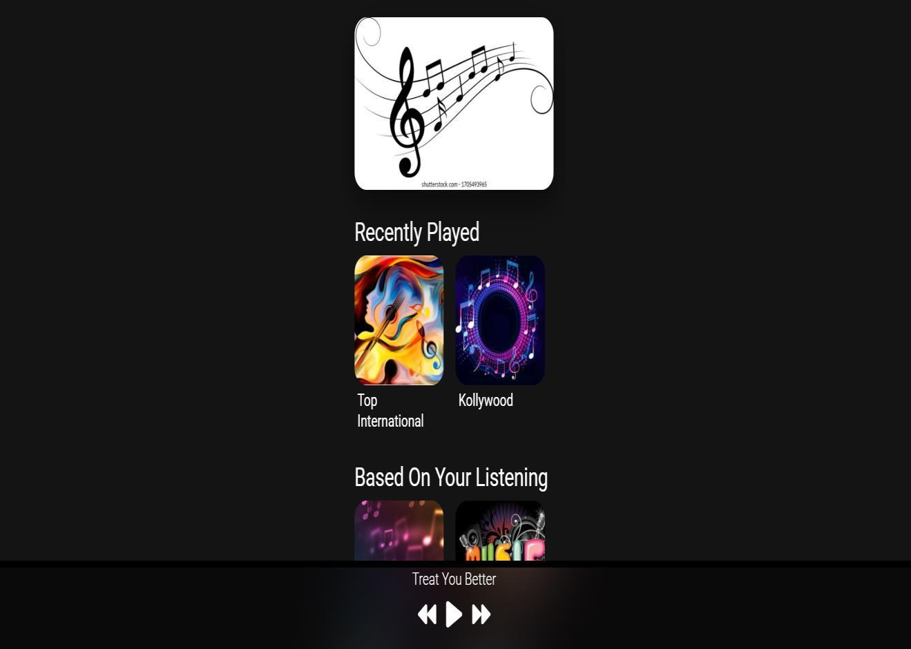

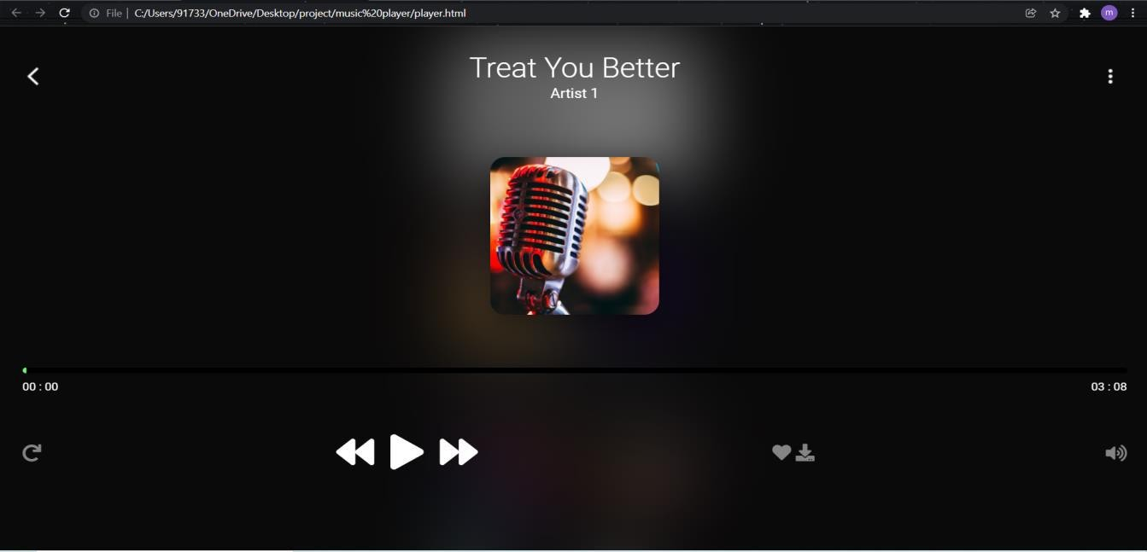

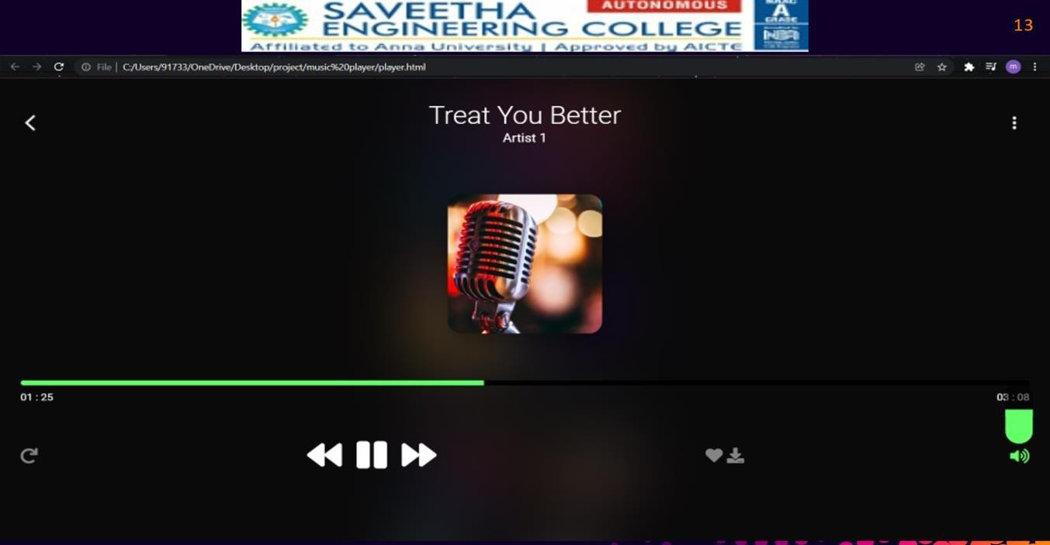

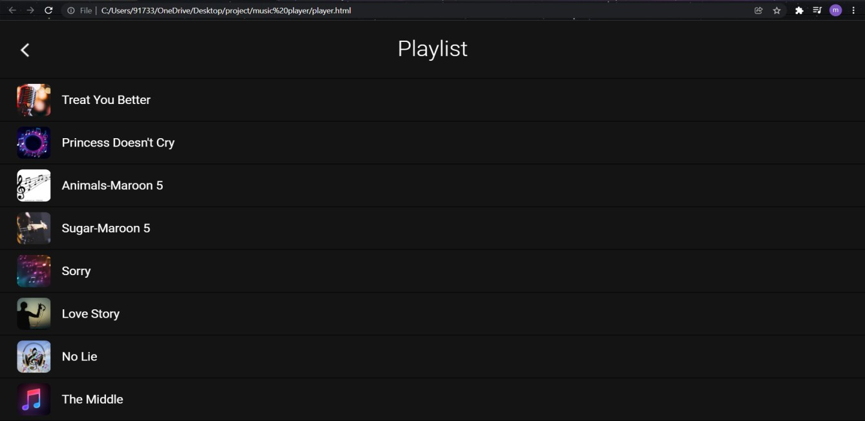

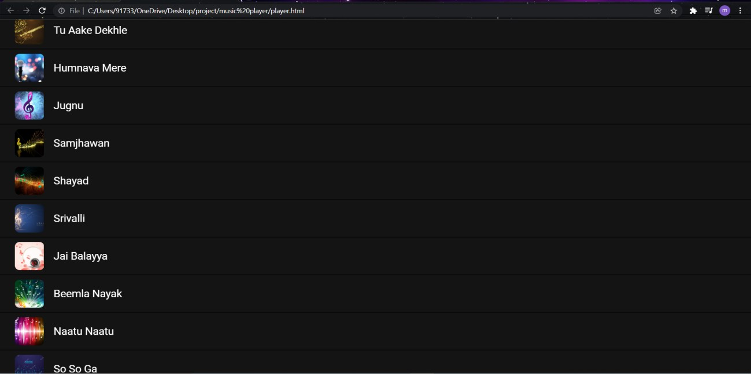

# CHAPTER 5

**TEST PLAN AND TESTING**

## TESTING

Test plan is a deliberate series of activities that is to be completed at some point of checking out. It includes status quo of valid take a look at case, framing of test system and collecting of all of the essential sources required to perform the check system as in keeping with plan and time table. The numerous assets include the equipments, the take a look at specimens and checking out environment relying at the type of testing to be executed and the various customers of the

machine.From ok method clustering visualization we will finish that aged folks are more likely to get cognitive impairment. From the dataset of 409 values 7 have severe dementia, forty five have moderate to moderate dementia.

## TESTING OBJECTIVE

The cause of testing is to find out errors. checking out is the method of trying to discover every manageable fault or weakness in a piece product. It gives a manner to check the functionality of components, subassemblies, assemblies and/or a completed product it's miles the process of workout software program with the cause of ensuring that the software program machine meets its requirements and consumer expectations and does now not fail in an unacceptable way. there are various sorts of check. each take a look at kind addresses a selected testing requirement

## TYPE OF TEST

* + 1. **Unit testing**

Unit testing involves the layout of take a look at cases that validate that the inner software good judgment is functioning well, and that application inputs produce legitimate outputs. All decision branches and internal code float ought to be validated. it's miles the testing of individual software devices of the application .it's far completed after the crowning glory of an person unit earlier than integration. that is a structural checking out, that is predicated on expertise of its construction and is invasive. Unit checks carry out fundamental tests at component degree and take a look at a selected business method, utility, and/or gadget configuration. Unit assessments make sure that

each particular course of a commercial enterprise manner performs correctly to the documented specs and carries clearly described inputs and expected effects.

## Integration testing

Integration assessments are designed to check incorporated software additives to decide if they genuinely run as one software. checking out is occasion pushed and is greater involved with the fundamental final results of screens or fields. Integration checks display that despite the fact that the additives were individually pleasure, as proven with the aid of effectively unit trying out, the aggregate of components is correct and steady. Integration trying out is in particular aimed toward exposing the problems that stand up from the combination of components. The undertaking of the combination take a look at is to test the additives or software packages, e.g. components in a software system or – one step up – software program programs.

## SYSTEM TEST

Gadget testing guarantees that the whole integrated software system meets requirements. It assessments a configuration to make sure acknowledged and predictable effects. An example of gadget trying out is the configuration oriented device integration check. system trying out is based totally on system descriptions and flows, emphasizing pre-driven process hyperlinks and integration points.

## White Box Testing

White field checking out is a trying out where in where in the software program tester has understanding of the internal workings, structure and language of the software program, or at least its cause. it's far motive. it is used to test regions that cannot be reached from a black field stage.

## Black Box Testing

Black box checking out is trying out the software program with none expertise of the internal workings, structure or language of the module being examined. Black field exams, as most different types of tests, ought to be written from a definitive source file, such as specification or necessities report, which include specification or necessities document. It’s miles a trying out in which the software program under check is treated, as a black box. You can’t “see” into it. The check gives inputs and responds to outputs with out thinking about how the software works.

## Unit Testing

Unit trying out is commonly performed as a part of a blended code and unit check section of the software lifecycle, even though it isn't always uncommon for coding and unit checking out to be conducted as distinct stages.

# CHAPTER 6

**6. RESULT AND OBSERVATION**

## RESULT

Hence the undertaking plays songs with all of the required buttons to play next song or preceding track and you can also trade the placement of the song And you could add that track in your favorites. it'll also show you lyrics of that specific song. And we used Sass , a stylesheet language that’s compiled to CSS. It lets in you to apply variables, nested guidelines, mixing , features, and extra, all with a totally CSS-compatible syntax. Sass facilitates preserve big stylesheets well- prepared and makes it easy to proportion layout within and throughout projects.

## OBSERVATION

To a song to play it fetches statistics from facts segment in vue object of java script record. And For each movement there is a way which performs the functionality of every action like play and pause, subsequent song and former tune, album cowl each issue paintings with json information which includes music name, track area and artist name YouTube URL, and Boolean value representing whether or not if it is favorited or now not. we simply have the template and the whole thing is dynamically loaded from the json object of information attribute of Vue object.

# CHAPTER 7

## CONCLUSION :

With an excellent ui and at less information cost we furnished a great music player and everything is running the manner it must be and there's no errors and it helps all the music files as well as it's also very compatible with mobiles additionally. consumers won’t get any ads and there won’t be any community troubles from our facet.

## References

1. F . Abdullahi .C .Kisha Hassan, “Design and Implementation of a web based music portal,” Journal of Applied Information system, vol.2 ,no,9,pp.June 2012.
2. Mathieu Barthes ,Lesha Zhang & Yongming,” A Web application for audience participation in live music performance”, International License, vol.4, July 11-15 2016.
3. Jaime Ramirez Castillo& M. Julia Flores,” Web-Based Music Genre Classification for Timeline Song Visualization and Analysis”, Citation information: DOI 10.1109/ACCESS.2021.3053864, IEEE Access.
4. [Omkar Vaidya](https://ieeexplore.ieee.org/author/37086510122); [Kunal Jadhav](https://ieeexplore.ieee.org/author/37088322583); [Rupesh Chaudhari,](https://ieeexplore.ieee.org/author/37088336721) Hand Gesture Based Music Player Control in Vehicle

[2019 IEEE 5th International Conference for Convergence in Technology (I2CT).](https://ieeexplore.ieee.org/xpl/conhome/9023468/proceeding)

1. [Krytron Chautala](https://ieeexplore.ieee.org/author/37086945215); Rephase; Sadananda Emotion-Based Music Player

[2019 5th International Conference on Engineering, Applied Sciences and Technology (ICEAST)](https://ieeexplore.ieee.org/xpl/conhome/8789432/proceeding)

1. [Shlok Gilda](https://ieeexplore.ieee.org/author/37086195220); [Husain Zafar](https://ieeexplore.ieee.org/author/37086338167); [Chintan Sony](https://ieeexplore.ieee.org/author/37086341167); [Kshitija Waghurdekar](https://ieeexplore.ieee.org/author/37086339344)

Smart music player integrating facial emotion recognition and music mood recommendation

[2017 International Conference on Wireless Communications, Signal Processing and Networking](https://ieeexplore.ieee.org/xpl/conhome/8292786/proceeding) [(WiSPNET)](https://ieeexplore.ieee.org/xpl/conhome/8292786/proceeding)